

VG Engine 101

Tutorial



16.10.2015

Contents

GameObjects 2

Components 2

Drawable component 2

Text Component 3

Animation Component 3

Physics Component 4

Your Own Components 5

Sound 7

Custom Shader 7

Input 8

Camera 8

Screen 9

Windows Version 10

# GameObjects

**Include**

#include “engine/game/gameObject.h”

**Creation**

*Example of creating a GameObject named “Foo”:*

GameObject *Foo = new GameObject(“Foo”); // Creating GameObject

Scene mScene = new Scene(); // Creating Scene (if not already created)

mScene->getObjectPool()->addGameObject(test); // Adding GameObject to the scene

See “Components” section on how to add components for your GameObject.

# Components

## Drawable component

**Include**

#include “engine/game/quadrangleComponent.h” // For drawable quadrangles

#include “engine/game/triangleComponent.h” // For drawable triangles

**Creation**

**With texture:**

// Creating quadrangleComponent with the texture “test.png”

QuadrangleComponent *quadre = Game::getInstance()->getFactory()->createRenderComponent<QuadrangleComponent>(“test.png”);

// Creating triangleComponent with the texture “test.png”

TriangleComponent *triangle = Game::getInstance()->getFactory()->createRenderComponent<TriangleComponent>(“test.png);

**Without texture: Coming Soon™**

**Remember!**

**If you create drawable component with texture it is loaded from Asset folder set in game project!**

## Text Component

**Include**

#include “engine/game/textComponent.h”

**Creation**

// Creating text component with font & size

TextComponent* Text = game->getFactory()->create(“arial.ttf”, 16u);

Text->setText(“test”); // Optional: Modify the text

Text->setColour(0, 0, 255); // Optional: Modify the color (numbers between 0 and 255)

MyTextObject->addComponent(Text); // Add textComponent to your GameObject

## Animation Component

**Include**

#include “engine/game/animationcomponent.h”

**Creation**

*Example of creating an animated GameObject named “animationObject”.*

// Create a new GameObject

GameObject *animationObject = new GameObject(“Animation”);

// Create QuadrangleComponent spritesheet for the animated GameObject

QuadrangleComponent *animationComponent = game->getFactory()->createRenderComponent<QuadrangleComponent>(“spritesheet.png”);

// Add the QuadrangleComponent to the GameObject

animationObject->addComponent(animationComponent);

// Add TransformComponent for the GameObject so it will be placed somewhere later

TransformComponent *animationTransform = new TransformComponent(Vector2<int>(int positionX, int positionY), Vector2<int>(int sizeX, int sizeY), float rotation);

// Add the transformComponent to your GameObject

animationObject->addComponent(animationTransform);

// Create and add the animationComponent for your GameObject so it will be animated

animationObject->addComponent(new AnimationComponent(float animationInterval, int rowCount, int columnCount, int total frameCount));

IMPORTANT!!

// Create and add AnimationSystem for animationComponents to work!

AnimationSystem *animationSystem = new AnimationSystem();

game->addComponentSystem(scene, animationSystem);

// Add the animated GameObject to the scene

scene->addGameObject(animationObject);

## Physics Component

**Include**

#include "engine/game/physicsSystem.h"

#include "engine/game/physicsComponent.h"

// Create transform component for physics component

TransformComponent *physicsTransform = new TransformComponent(Vec2f(100, 100), Vec2f(64, 64));

// Create QuadrangleComponent

QuadrangleComponent *physicsQuadrangle = new QuadrangleComponent("sample.png");

// Create new physics polygon component with dynamic body

PhysicsComponent *physicsComponent = new PhysicsComponent(physicsTransform, PhysicsComponent::DYNAMIC, *Vec2f(64, 64)*);

**NOTE Last parameter is optional, if you don’t pass them, physic objects collision will be the same size as its defined in the transform component (same size as texture)**

// Add physics component to physics gameobject physicsTestObject ->addComponent(physicsComponent);

// Add transform to physics gameobject physicsTestObject ->addComponent(physicsTransform);

// Add QuadrangleComponent to physics gameobject physicsTestObject-

>addComponent(physicsQuadrangle);

// Get physics system

PhysicsSystem *system = Game::getInstance()->getSceneManager()->getActiveScene()->getComponentSystemManager()->getSystem<PhysicsSystem>();

// Create physics borders, there is no borders by default

system->createBorders(0, 0, Screen::getX(), Screen::getY());

// Set default gravity

system->setGravity(Vector2<float>(0, -9.81));

## Your Own Components

*Example of creating a component called “MyComponent”*

**MyComponent.h**

#include <engine/game/component.h> //Include the base header

class MyComponent :public vg::Component //Public to vg::Component

{

public:

 TestComponent();

~TestComponent();

};

*Example of creating a System called “MySystem”*

**MySystem.h**

#include “engine/game/system.h”

using namespace vg;

class MySystem : public System

{

ShipSystem();

~ShipSystem();

void update(

};

**MySystem.cpp**

#include “MySystem.h”

#include “engine/game/game.h”

using namespace vg;

MySystem::MySystem() :System()

{

// Add your own code here

}

void MySystem::update(std::vector<vg::gameObject*> *gameObjects, float deltaTime)

{

if ((*it)->getName() == “mygameobject”)

{

// Add your own logic here

}

}

**Usage**

*Example of calling your own component in main.cpp*

MyComponent *myComponent = new MyComponent();

object->addComponent(myComponent);

MySystem *system = new MySystem(); // Remember to include

# Sound

**Include**

#include “engine/sound/AudioManager.h”

**Creation**

vg::sound::Sound* testSound = new vg::sound::Sound(“shoot.mp3”); // Creating a new sound

**Usage**

Game::getInstance()->getAudioManager()->addSound(*testSound); // Playing the made sound object

# Custom Shader

**Creation**

Place the shader soure files to “ProjectFolder/assets/shaders”.

**Usage**

Game::getInstance()->getGraphics()->switchShader(“vertex.glsl”, “fragment.glsl”);

# Input

**Include**

#include “engine/input/keyboard.h” // For keyboard

#include “engine/input/mouse.h” // For mouse

#include “engine/input/sensor.h” // For android sensors

#include “engine/input/touch.h” // For android touch

**Usage**

vg::input::Keyboard:: // For keyboard

vg::input::Mouse:: // For mouse

vg::input::Sensor:: // For android sensors

vg::input::Touch:: // For android touch

**For example:**

vg::input::Touch::getIsReleased() // Returns whether touch is being released from the screen

# Camera

**Include**

#include "engine/graphics/camera.h"

**Usage**

// Move camera focus position

vg::graphics::Camera::move(Vector2<float> value);

vg::graphics::Camera::setPosition(Vector2<float> value);

vg::graphics::getPosition();

// Zoom the camera

vg::graphics::Camera::zoom(float value);

vg::graphics::Camera::setZoom(float value);

vg::graphics::Camera::getZoom();

**For example:**

using namespace vg::graphics;

Camera::zoom(0,5f); // Zoom in 50%

Camera::move(Vector2<float>(100, 0)); // Move camera 100 units right

# Screen

Screen class has two sizes. Real size is actual screen or window resolution in pixels. Virtual size is the resolution in TransformComponent coordinate units. If you want your game look same on all resolutions use virtual resolution instead of the real one.

**Include**

#include "engine/graphics/screen.h"

**Usage**

// Virtual resolution in TransformComponent coordinate units

vg::graphics::Screen::getSize();

vg::graphics::Screen::getX();

vg::graphics::Screen::getY();

vg::graphics::Screen::setSize(Vector2<int>(width, height));

// Actual resolution in pixels

vg::graphics::Screen::getSize();

**For example:**

using namespace vg::graphics;

Vector2<int> resolution = Screen::getSize(); // Get the virtual screen size

# Windows Version

**Usage**

Select Win32 as solution platform.

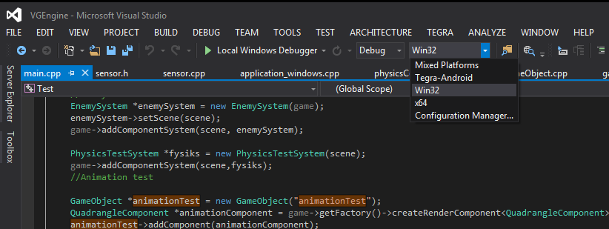

If Win32 doesn’t appear, do the following:

Build -> Configuration Manager

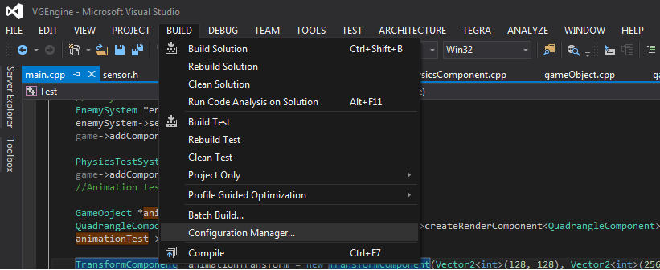

Active solution platform -> Choose “Win32” and then Press Close

